Owner’s Manual and Operating Instructions

6ft. Steel Dump Insert

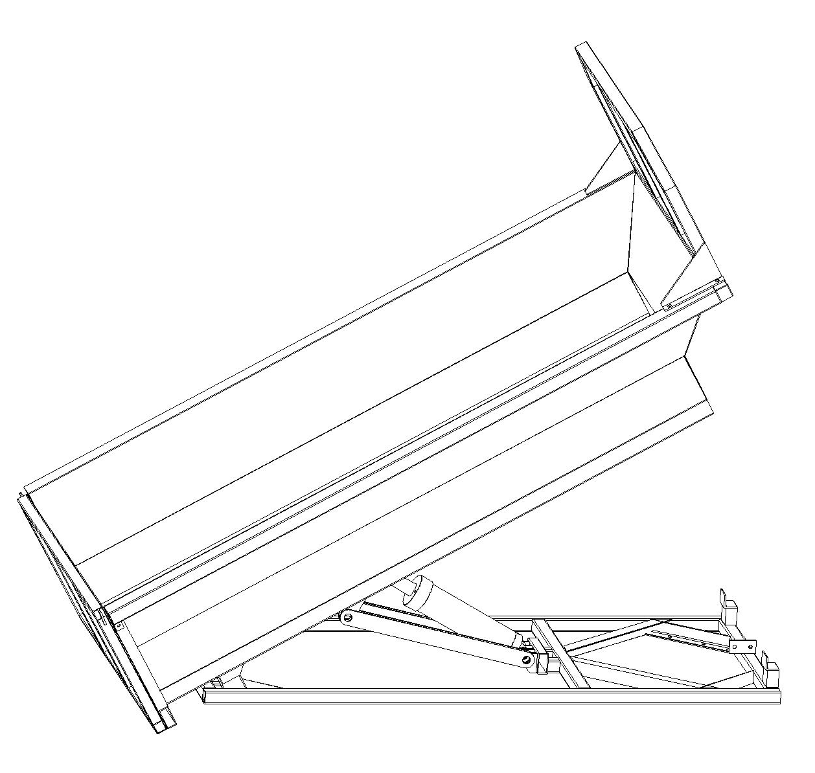

Read Owner’s Manual Completely Prior to Installation

Contents

General Specification and Features………………………………………….3
Warning and Safety Instructions……………………………………………...4-5
Safety Decals…………………………………………………………………...6
Location of Safety Decals……………………………………………………..7
Installation Instructions………………………………………………………..8-13
Operation Instructions…………………………………………………………13
Maintenance……………………………………………………………………14-15
Parts Drawing……………………………………………………………………16
Parts List…………………………………………………………………………17

GENERAL SPECIFICATION AND FEATURES

Empty weight: (approx.) 305kg / 670lbs
Payload capacity: 2730kg / 6000lbs
Bed floor size : 2120 x1220mm
Overall dimensions: 3040 x1833x1262mm
Volume capacity: 1.08M³ / 1.41cubic yards
Cycle up time, loaded: 30 seconds
Dump angle: 48 degrees
Side steel: 2mm
Deck steel: 3mm
Energy source: Vehicle 12V battery
Lubrication: Thread-in grease fittings on pivots

WARNING AND SAFETY INSTRUCTIONS

This symbol means ATTENTION!
Become Alert!
Your safety is involved!
Please read and understand completely before doing!

BEFORE PERFORMING MAINTENANCE OPERATIONS, PARK VEHICLE ON LEVEL GROUND.
SET PARKING BRAKE, SHUT OFF ALL POWER, AND MAKE SURE ALL MOVEMENT HAS STOPPED.
IF BODY IS RAISED, IT MUST BE SECURELY BLOCKED SO IT CANNOT COME DOWN.
SUPPORT BLOCKS MUST NOT BE REMOVED UNTIL THERE IS NO DANGER OF ANYONE BEING UNDER BODY WHEN BODY IS LOWERED.
Improper use of this equipment can result in serious injury. To reduce this possibility, give complete and undivided attention to the job at hand, and follow these safety instructions.

PREPERATION:
1. Know your controls. Read this instruction manual. Learn how to stop the equipment quickly in an emergency.
2. Do not allow children to operate machine; nor adults to operate it without proper instructions.
3. Keep all individuals not involved in the use of the equipment a safe distance away.
4. A copy of this manual should be available in the cab at all times.
.
OPERATION:
1. Do not exceed rated capacity 6000lbs.
2. Vehicle, dump insert and cargo mush not exceed manufacturer’s gross vehicle weight rating.
3. Observe and shut off all equipment controls before starting engine so equipment will not unintentionally operate when engine is started.
4. Always check area around machine before engaging or operating controls.
5. Vehicle should be on a flat surface prior to raising bed. Operation on slippery uneven terrain may result in equipment damage or personal injury.
6. Know the material you are hauling and plan your haul to avoid “set up” or freezing of the load in the dump body. In the event that a load becomes stuck or frozen in the body, do not abuse, overload, or damage the truck, hoist, or body in efforts to quickly free the load. It may be necessary to thaw indoors to safely remove such a load.
7. In the event that shoveling or mechanical means are used to free the stuck load, be sure the load is NOT hoisted and the tailgate, if opened, is secured properly before starting this effort. If hoisted, a stuck load, or portion, could release unexpectedly and cause injury to personnel or damage to the body, truck, or surroundings.
8. Some materials such as mud, or sludge, may shift easily when wet, resulting in increased tendency to overturn the truck on curves, unstable ground, or side slope situations. Reduce load size, speeds, and side slopes, and use care and planning to avoid this potential occurrence.
9. Unload the body and securely prop and block a raised body before any service, inspection, or repair work is started.

WARNING AND SAFETY INSTRUCTIONS

10. Be sure the power wire is disengaged from battery before traveling. Failure to disengage the wire form battery may allow the dump body to rise unintentionally. This may lead to loss of vehicle control, accidental injury and/or property damage.
11. Empty material prior to handling the body.
12. Always wear relatively tight and belted clothing when operating equipment. Loose jackets, shirts sleeves or other loose clothing should not be worn because of the danger of catching them in moving parts or controls.
13. Stop and inspect equipment if unusual movements, sounds, or noises are observed. Repair damage before restarting and operating the equipment.
14. Disengage power to all operating equipment: (1) before leaving operator’s position, (2) before making any repairs or adjustments, or (3) when not in use.
15. Take all possible precautions when leaving the equipment unattended; such as shifting vehicle out of gear, setting parking brake, shutting off engine and removing key. Never leave raised body unattended.

SAFETY DECALS

NOTICE:
1. It is the responsibility of the Owner of the Dump Body to replace any or all safety decals which become unreadable or otherwise defaced.
2. Read and observe all “Danger” and “Caution” safety decals appearing on equipment.
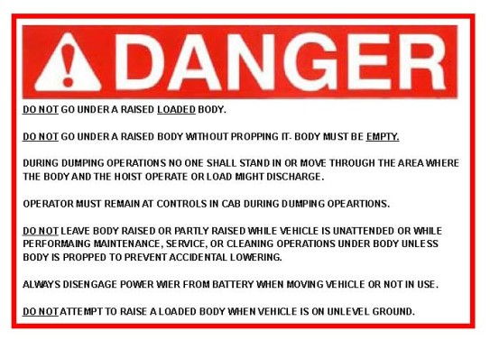
The following safety decals appear in various locations on your Dump Body, refer to page 7 for approximate locations.

DECALS 1

DECALS 2 DECALS 3
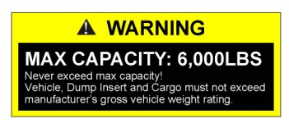
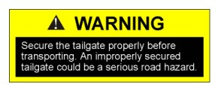

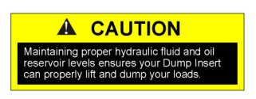
DECALS 4 DECALS 5
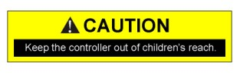

DECALS 5


LOCATION OF SAFETY DECALS
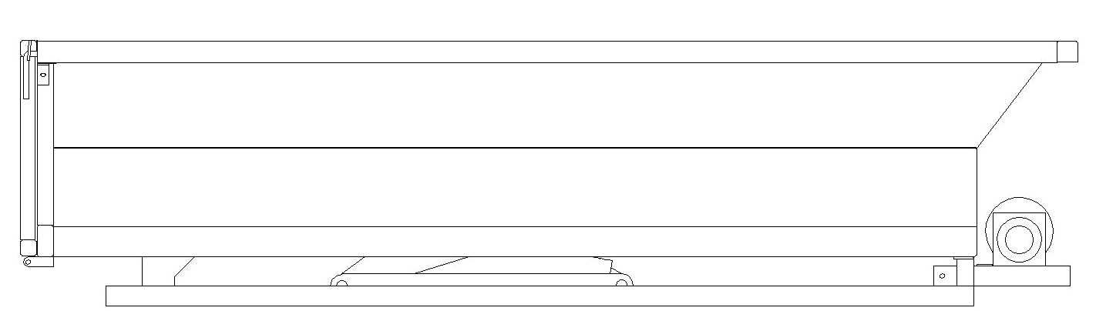
Decal 6

Decal 1
Decal 2

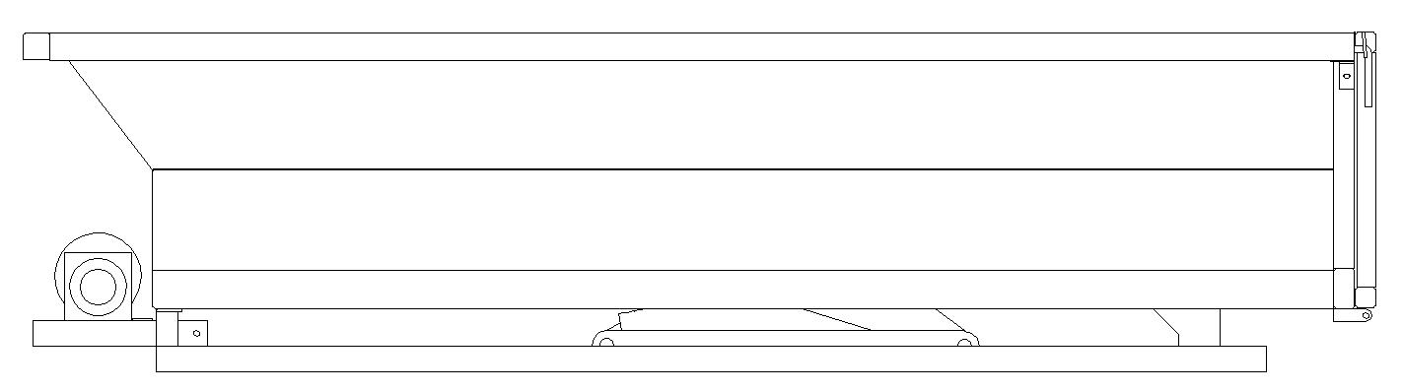

Decal 6 Right View

Decal 2
Decal 1

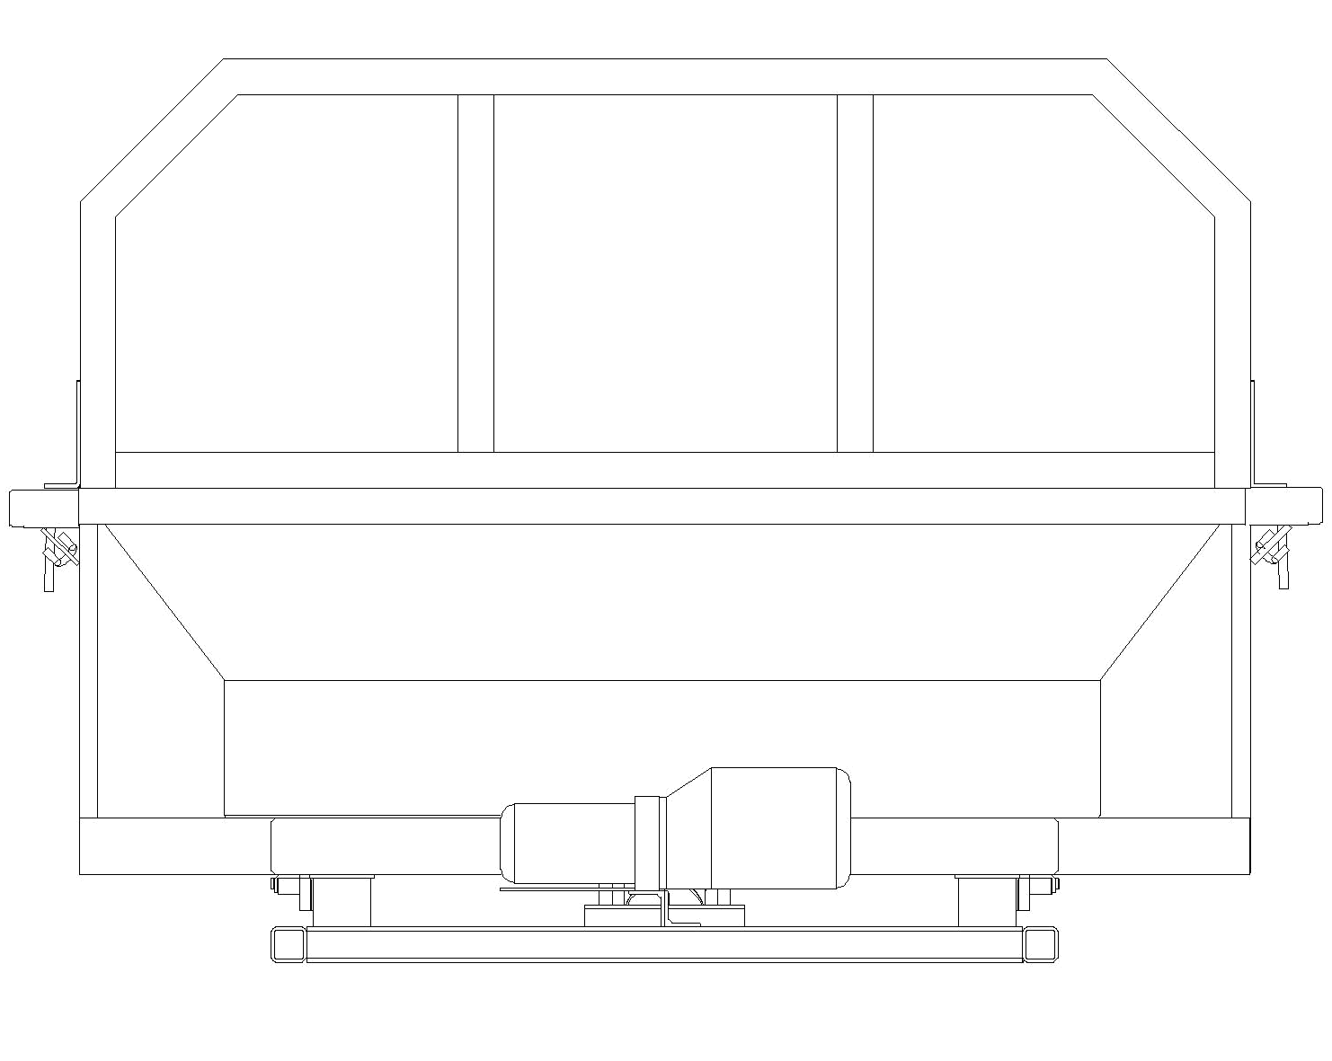
Left View

Front View
Decal 5
Decal 4

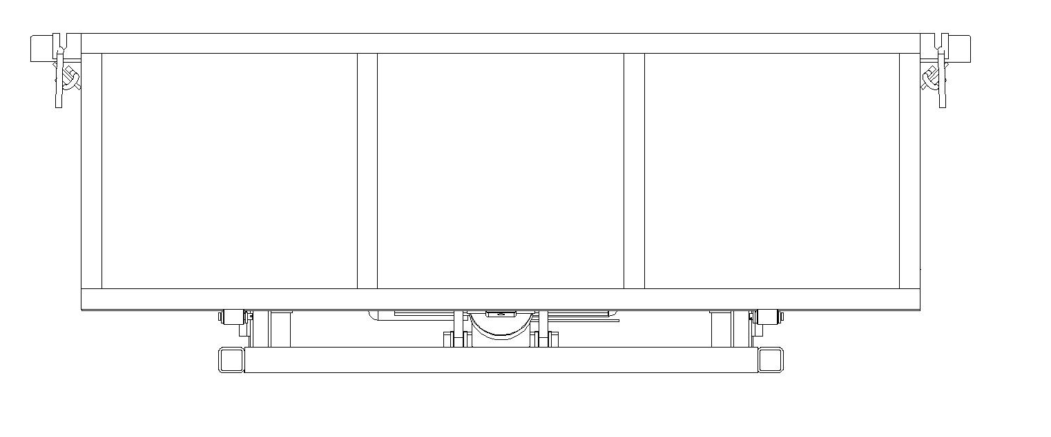
Decal 3
Decal 3

Back View
Decal 2
Decal 1
Decal 6

INSTALLATION

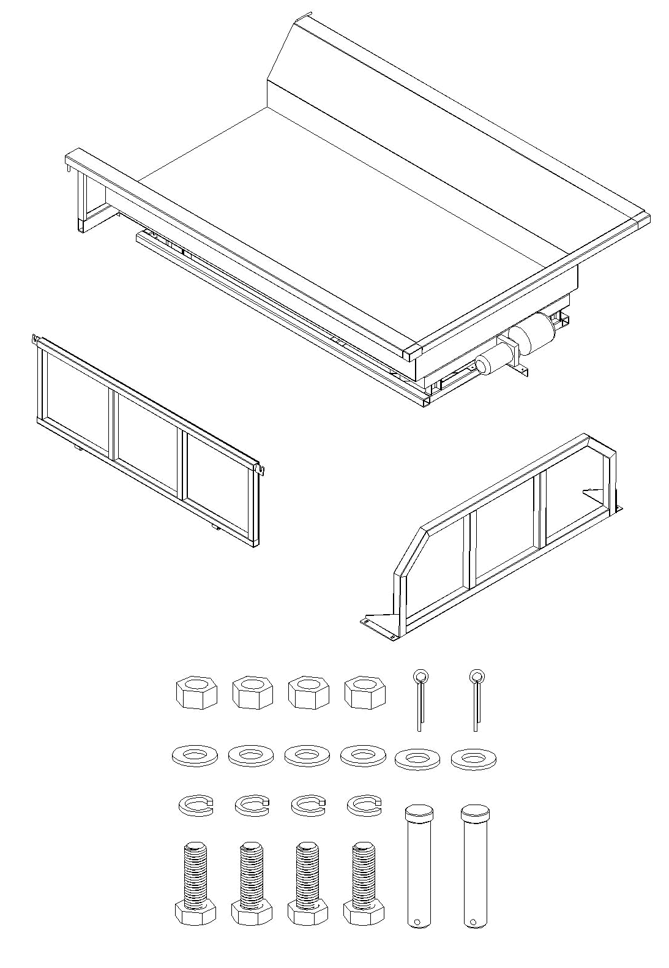
After receiving you dump insert ensure that necessary components and hardware have been shipped and that unit is not damaged.
Dump Body

Power Unit

Tailgate

Cab Shield

Hex Nut M12
4PCS
Cotter Pin 3x20
2PCS

Flat Washer Ø12
6PCS

Spring Washer Ø12
4PCS
Pin
2PCS

Hex Bolt M12x35
4PCS

INSTALLATION

Step 1: Install the power unit
.

1. Attach #35 Power Unit Mounting Frame and negative wire to #41 Bottom Frame using #39 Hex Bolt M10x35, #37 Flat Washer Ø10, #38 Spring Washer Ø10 and #40 Nut M10.
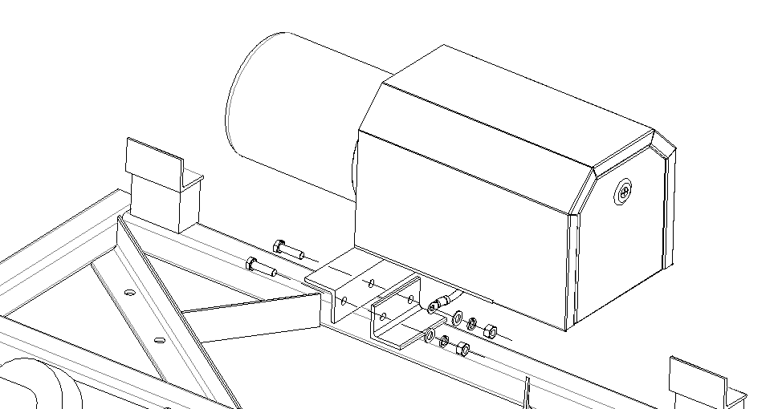

39
41

negative wire

37

38
40

2. Attach #29 Oil Tube to Port

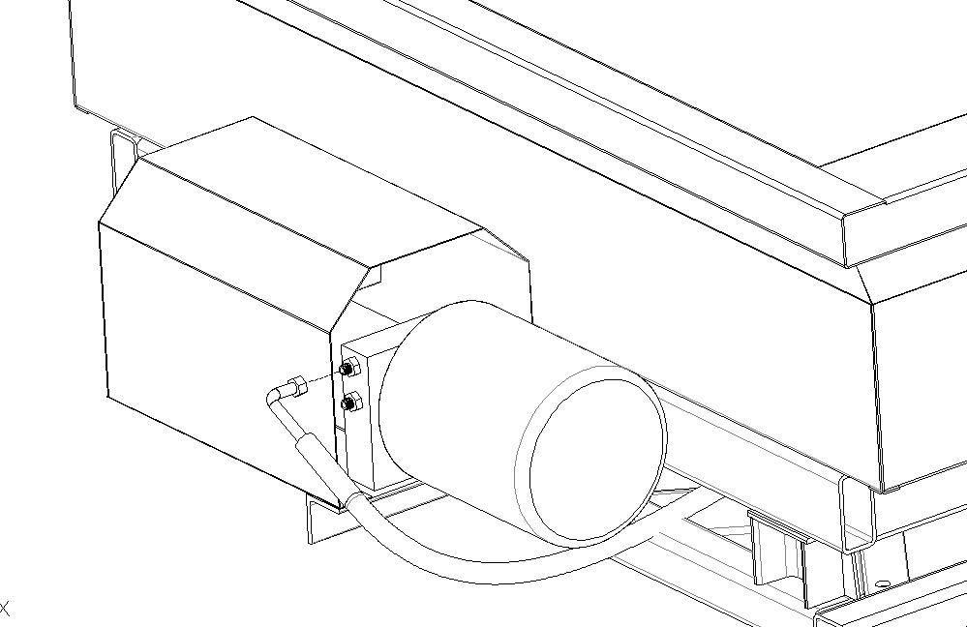

Port

29

INSTALLATION

Step 2: Measure the positions of eight drilled holes in bottom frame.
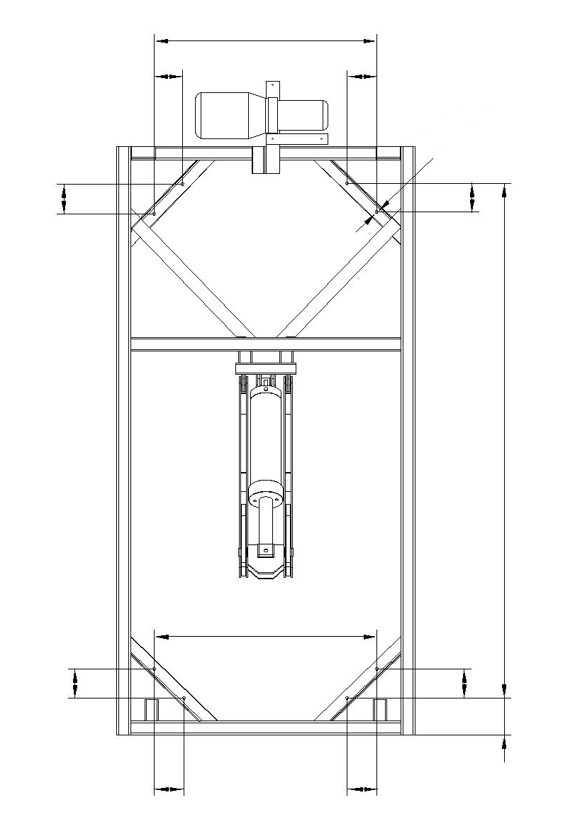

INSTALLATION
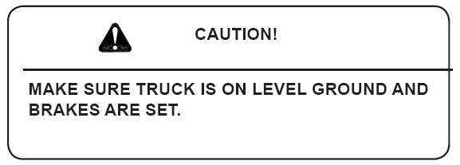
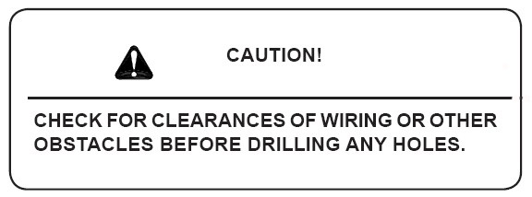

Step 3: Make sure the truck being used is on level ground. Remove tailgate from truck.
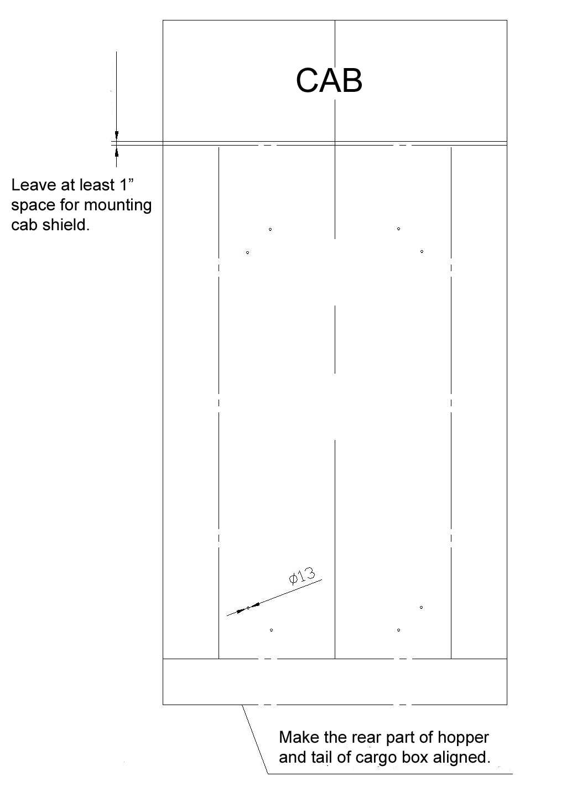
Drill eight Ø13 holes in the corresponding position of truck bed.

INSTALLATION

Step 4: Attach dump insert to truck bed using the proper bolts, nuts and washers. (Not provided)
WARNING Prop dump body before assembling.

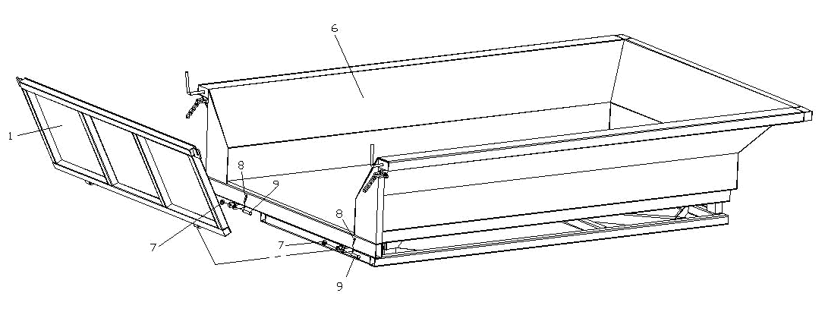
Step 5: Attach 1# Tailgate to #6 Dump Body using #7 Flat Washers Ø12, #8 Cotter Pins 3x20 and #9 Tailgate Pins.

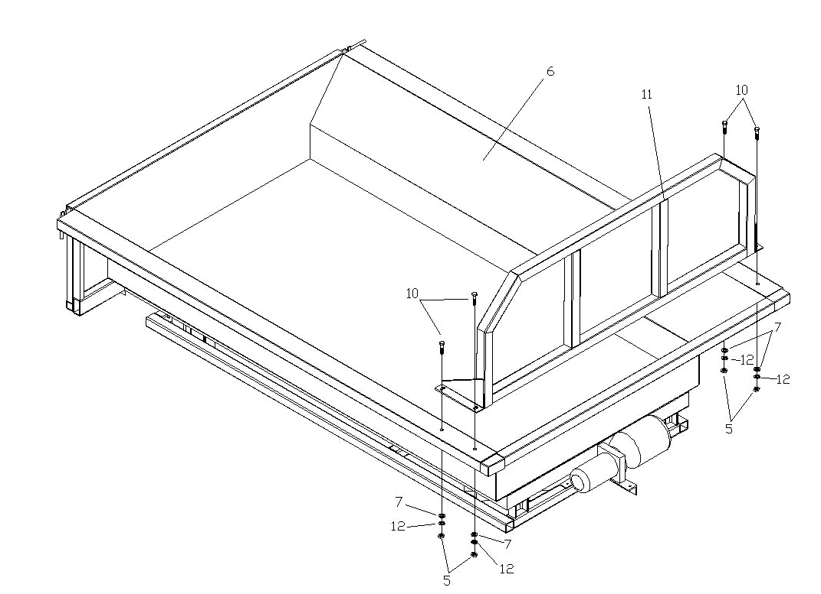
Step 6: Attach # Cab Shield to #6 Dump Body using #10 Hex Bolts M12x35, #7 Flat Washers Ø12, #12 Spring Washers Ø12 and #5 Nut M12.

INSTALLATION

Step 7: Connect electric wire of power unit to positive pole of truck battery. Make sure bottom frame and truck bed are fastened.

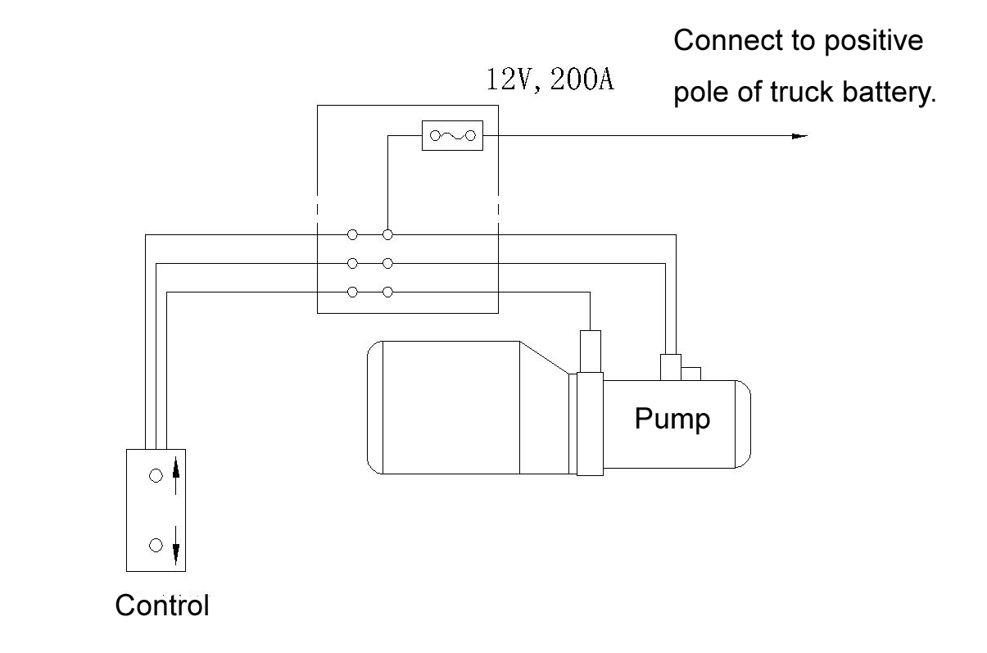

OPERATION

- Add 5 litres hydraulic oil to oil tank before use.
- Grease fittings if needed.
- Press up button to raise dump body, release up button to stop dump body, press down button to lower dump body.
WARNING: Release up button when dump body reaches the highest position, power unit will be damaged if the current is switch on for long time.

MAINTENANCE
DANGER!
BEFORE PERFORMING MAINTENANCE OPERATIONS, PARK VEHICLE ON LEVEL GROUND.
SET PARKING BRAKE, SHUT OFF ALL POWER, AND MAKE SURE ALL MOVEMENT HAS STOPPED.
IF BODY IS RAISED, IT MUST BE SECURELY BLOCKED SO IT CANNOT COME DOWN.
SUPPORT BLOCKS MUST NOT BE REMOVED UNTIL THERE IS NO DANGER OF ANYONE BEING UNDER BODY WHEN BODY IS LOWERED.

Daily Check List:
-Check the battery according to truck manufacturers recommended maintenance.
-Grease fittings every month or as needed.
-Use high grade, non-foaming hydraulic oil
-Check for oil leaks.
-Inspect for loose bolts.
-Inspect safety / mounting hardware for deformed or damaged components.
-Inspect for damaged components.

Seasonal Check List:
-Check and clean electrical connections.
-Inspect for damaged or cracked hoses.
-Changing of hydraulic oil
-Wash and wax to maintain finish.
-Check all fasteners for tightness

MAINTENANCE
MAINTENANCE GREASE POINT LOCATION GUIDE
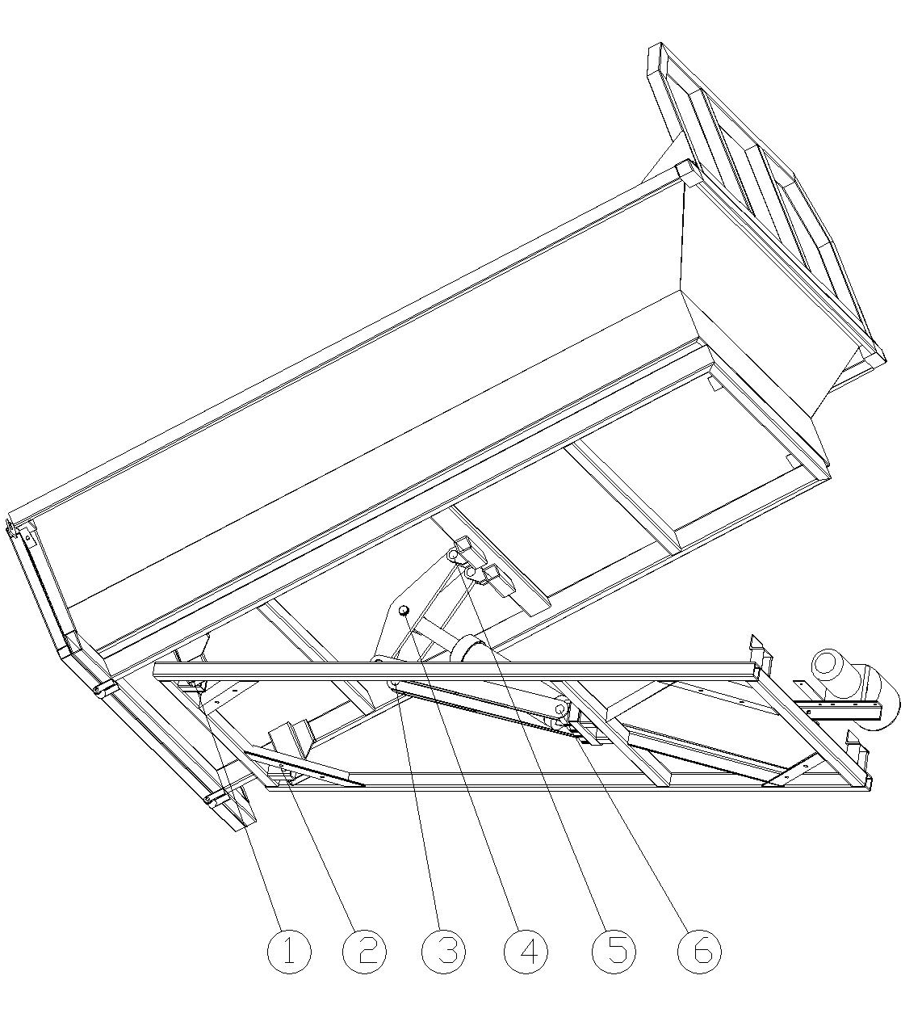

PARTS DRAWING
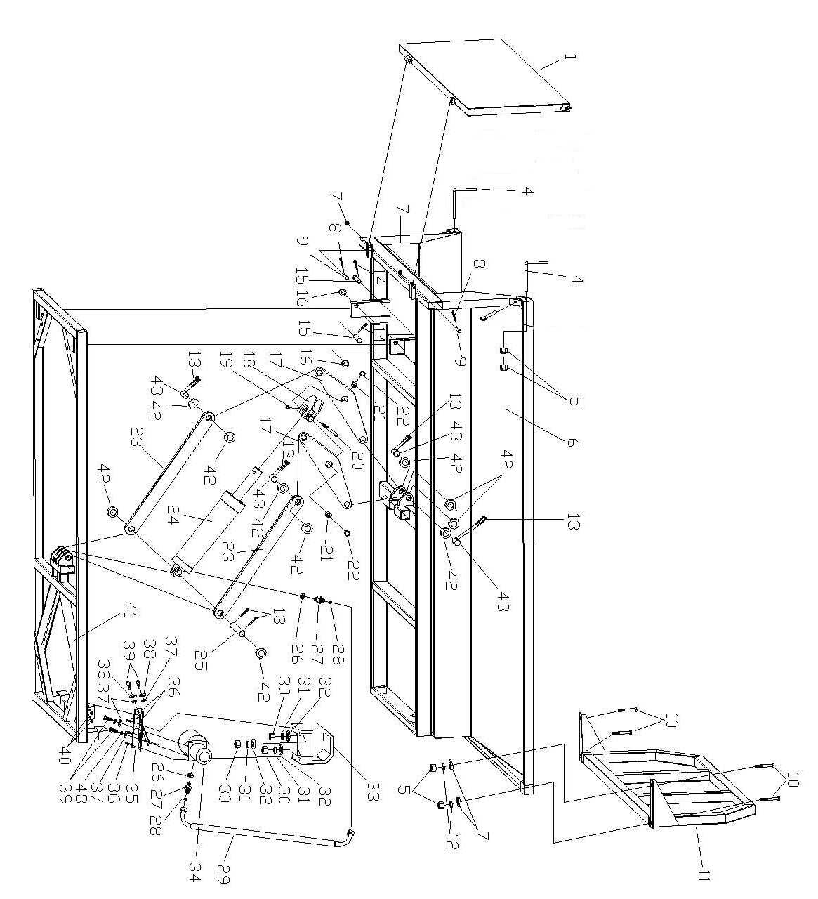

PARTS LIST

PARTS# | DESCRIPTION | QTY
1 | Tailgate | 1
4 | Pin | 2
5 | Nut M12 | 8
6 | Dump Body | 1
7 | Flat Washer Ø12 | 4
8 | Cotter Pin 3x20 | 2
9 | Tailgate Pin | 2
10 | Hex Bolt M12x35 | 4
11 | Cab Shield | 1
12 | Spring Washer Ø12 | 4
13 | Cotter Pin 3x40 | 10
14 | Cotter Pin 3x30 | 2
15 | Pivot Pin | 2
16 | Flat Washer Ø20 | 2
17 | Triangular Board | 2
18 | Cylinder Hood | 1
19 | Lock Nut M10 | 1
20 | Hex Bolt M10x75 | 1
21 | Composite Bearing 30x18 | 2
22 | Circlip 30 | 2
23 | Rod | 2
24 | Cylinder | 1
25 | Long Pin 3x220 | 1
26 | Bonded Washer Ø14 | 2
27 | Tube Joint | 2
28 | O Ring | 2
29 | Oil Tube | 1
30 | Nut M6 | 3
31 | Spring Washer Ø6 | 3
32 | Flat Washer Ø6 | 3
33 | Power Unit Shield | 1
34 | Power Unit | 1
35 | Power Unit Mounting Frame | 1
36 | Hex Bolt M6x20 | 3
37 | Flat Washer Ø10 | 4
38 | Spring Washer Ø10 | 4
39 | Hex Bolt M10x35 | 4
40 | Nut M10 | 2
41 | Bottom Frame | 1
42 | Flat Washer Ø30 | 10
43 | Short Pin Ø30x54 | 4

